Spring Boot with Initializer

- Note: In Your Eclipse IDE you can go to Help, Eclipse Marketplace and here you can search up plugins to download. Here search for Spring Tool Suite and download it. Once you do you can refresh and now you will get access to your Spring Boot Dashboard that is the green icon next to your source tab at the top.
- If you click on your Spring Boot Dashboard it will open up your dashboard in your console and it will show you all the Spring Boot projects you have in your workspace. You can right click on each project to run, stop, and restart your TomCat embedded server.
- Note: Search up spring.io and in the guides you click on Building a RESTful Web Service and you can follow those steps. We are doing the same example for this project.

- Lets create a Spring Boot Project using Initializer:
- Open your Spring Initializer and lets begin creating a Spring Boot project that is used for RESTful Web Service.
- Note: When you think of what makes a project RESTful. Think every time you hear RESTful you should be thinking about those Http methods like GET, POST, DELETE etc.

- In your Spring Initializer we are going to select Maven as our build tool so it’s a Maven Project with a Pom.xml file.
- Going to select Java as our language.
- For this version we will select 3.2.9
- Group we will use an example reverse domain name.
- Artifact Is the project name so for this project we will name it restfulweb
- Description can give a simple description of what this project is
- Packaging: We will choose jar
- Version: Our java version we will choose 17.

- Now in the right corner instead of before where we had to get our Maven dependencies from Maven Repo. Here can search up the Maven/Spring dependencies that we need for our project by name and import then to build our project and once our project builds. Whatever dependency we choose it will be in our Pom.xml file.
- One external dependency that we choose can have many internal dependencies within.
- So for our dependency search up Spring Web because we are building a Spring Boot project that uses RESTful Web Service

- Looks like this:
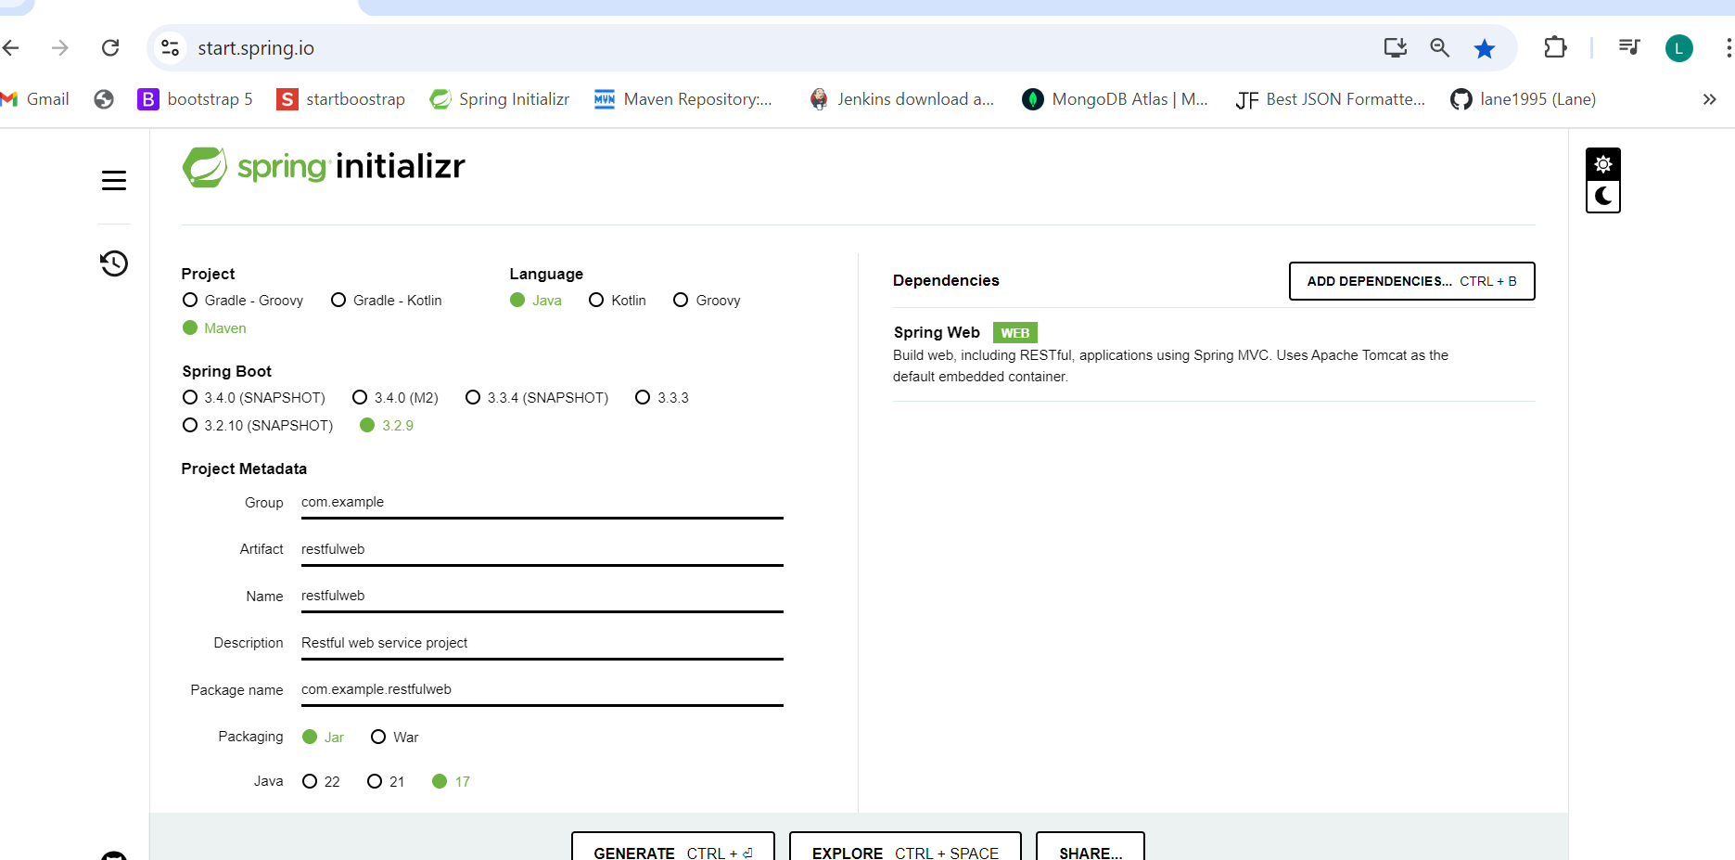

- Generate the Spring Project:
- Once finished you can now click generate this will download a zip file. You click on that file and extract all that will unzip the file and browse where you want that final unzipped file to be in your directory.
- Then in your Eclipse IDE you go to file, import, and then select existing maven project and it will import this Maven Structured project with Spring Boot Dependencies into your Eclipse Workspace.

- Pom.xml file in your Project looks like this:
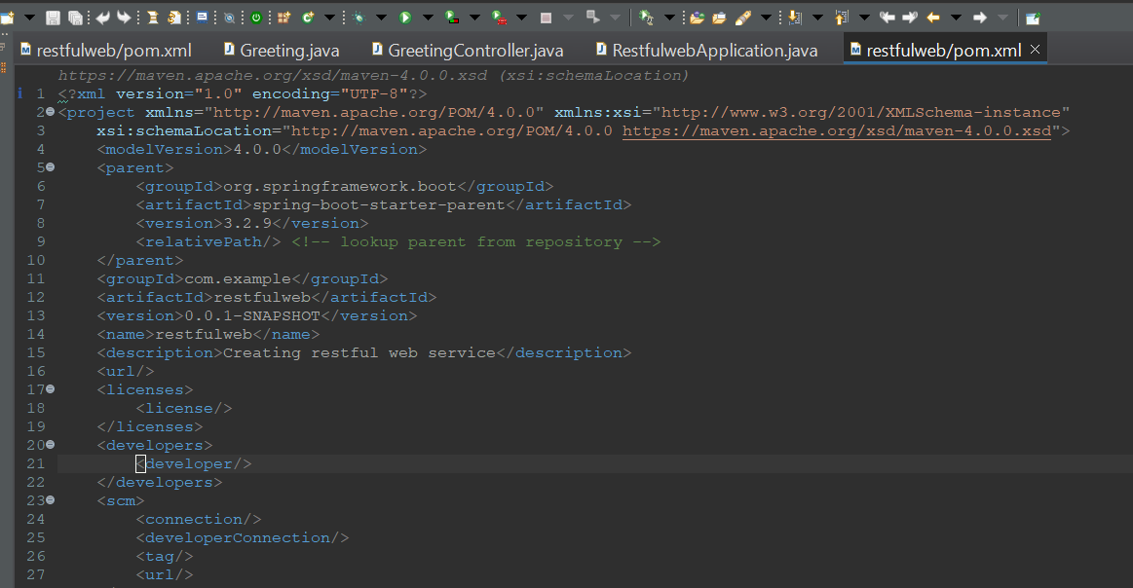
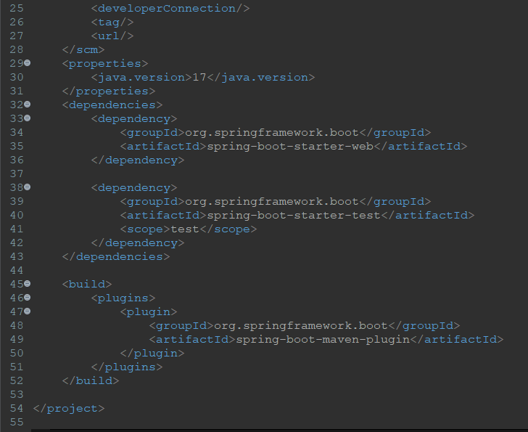

- Notice that the dependencies that you imported are there plus the maven build is automatically done for you so you don’t need to do that.
- Your project name in your explorer to the left will now say boot letting you know that this is a Sprint Boot project as well as a Maven because the M icon is in your project name as well. The Boot next to your name will only appear if you have the Spring Tool Suite Plugin in your Eclipse IDE.
- If you add this Project to your GitHub repository it will also show the location of the repository of where this project is located. Please hit refresh once uploaded to repository in your Eclipse and you will see the changes. Gitignore in your Github ignores all the extra files in your project that are not needed to be pushed into your remote repository. Your repository name that you create in Github should be the same name as the project you create so its easy to find.
- Now you project in explorer looks like this:
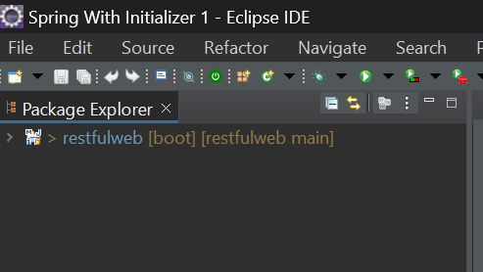

- Your project is no different in terms of directory from a Maven Project. Because even though we used Spring Boot dependency to make this a Spring Boot project, this is still a Maven project as well and the folder structure is the same.

Quick Run down of Project Structure
- Application.properties : This file is located in your Src/main/resource and this file is used for configurating different properties of application. Like here you change the port number of your server and also configure your database connection properties.
- Src/test/java : This is where your testing goes just like before and remember that it has the same package as in your Main. They need to be the same package of what you are wanting to test.
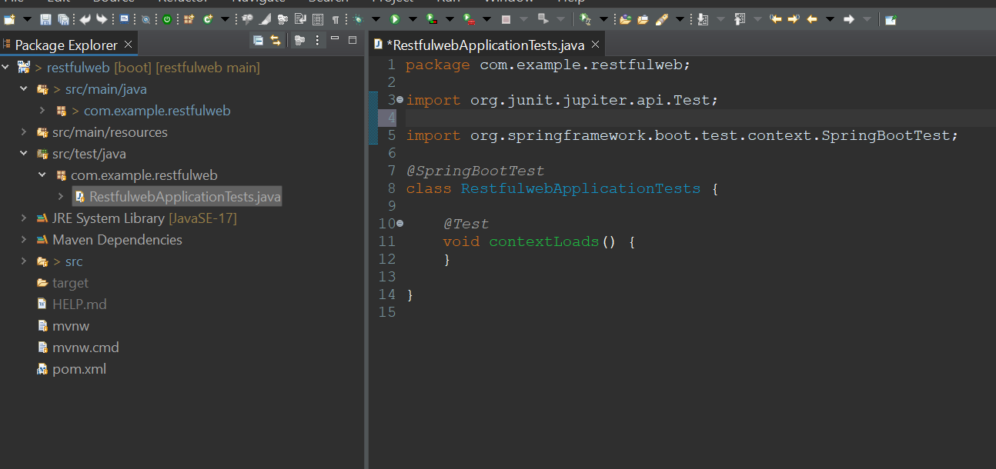

- If you notice that the package name in the main src folder and test folder are the same. And in the test folder you use the same class name of what you are wanting to test but just at the word Test to it so test class and the class you want to test are aligned
- @SpringBootTest this annotation in the test class shows your spring boot to test.

- What will we be doing in this project?
- We are going to create a web service that will accept HTTP GET requests at http://localhost:8080/greeting localhost 8080 is default and the /greeting is the endpoint we are going to give in our method located in our Controller class.
- And it will response with JSON in the representation of a greeting for example
Hello John

- Create a record:
- We have never created a record before. We are not going to create different packages this time so in your src/main/java in that default package, right click on that package, and create a record.
- Record: Record is a class that is immutable. Meaning that the content cannot be changed. Think of your records in school, how if you had a 3.5 it cannot be changed to a 4.0 once made. We are going to name this record called Greeting.

This is what we will be passing in this record for this project
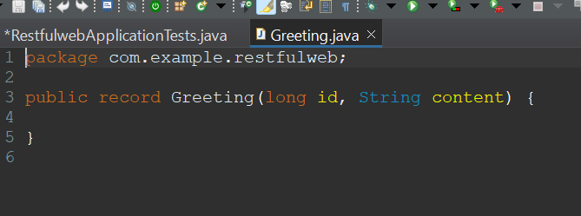

- id: This field is a unique identifier for the greeting.
- content: This is going to be the textual representation of the greeting.
- Information about Creating a Resource Controller:
- In Springs approach to building RESTful web services,
HTTP requests are handled by the Controller.
- Thes components are identified by using the @RestController annotation above the class name. @RestController is a combination of @Controller and @ResponseBody annotations. SO with the @RestController annotation all the methods inside this class are referred to as Controller methods that have a ResponseBody and @ResponseBody means that this class and all of its methods inside represent a web controller but also automatically returns to the front end or whatever is calling it a response.

- @ResponseBody: This annotation tells a controller that the object returned is automatically serialized into JSON and passed back into the HttpResponse object. Meaning that if we pass a Java Object it will transform this Object into a JSON object and is now able to passed to the front end. So this annotation indicates a method within the annotated class, that the method return value should be bound to the web response body.
- @Controller: This is used to define an entrance point for a Spring Web Application.

- What is a web response body?
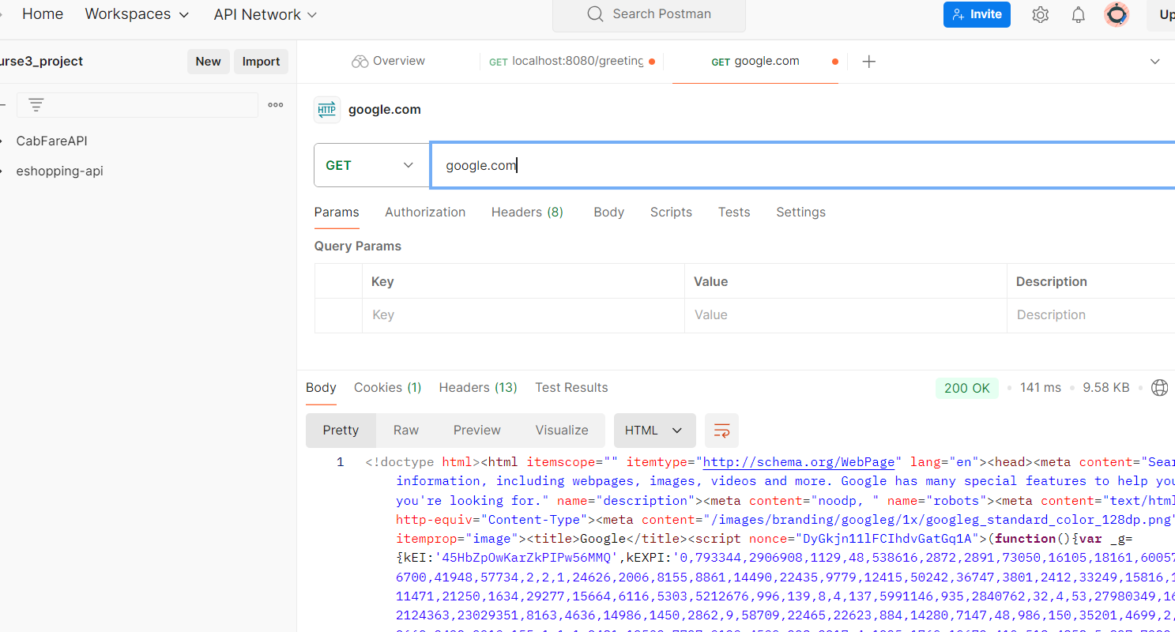
- In the above example I used google.com and used GET method in Postman. And what you see is a response in the body. This is known as the response body. Which as of now is the html document. And we want to send a response body that looks like this
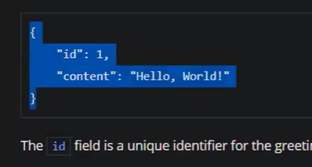
- This Is the response we want to send which is JSON format to the Response Body. And Not HTML.

Real quick take a look at this page:
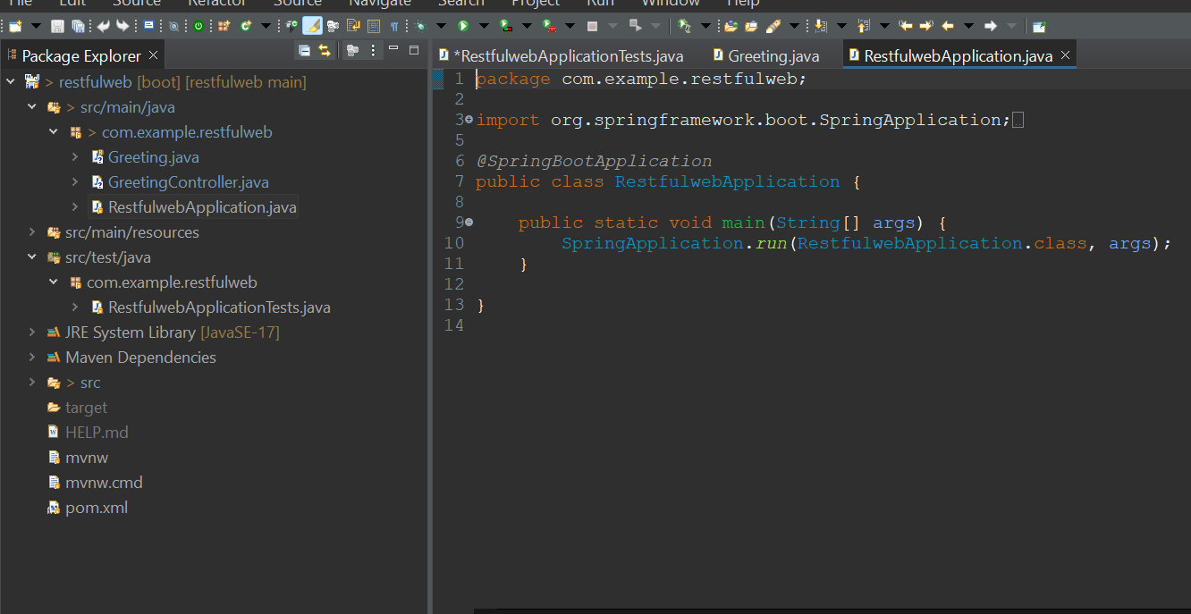

- This is your default main method for running application in your src/main/java folder. The @SpringBootApplication annotation is a Super Annotation that has multiple annotations combined just like @RestController. In @SpringAnnotation this comes with one of the annotations called @CompoentScan
- @CompoentScan: This annotation is used by Spring to automatically discover beans and components. Which are then automatically instantiated and wired into your application context(which we don’t need to configure anymore) when the application starts.
- And @RestController is a candidate for a @Component meaning that @SpringBootApplication scans our @RestController annotated class and renders the objects created inside automatically. So its like creating the beans for us without having to configure them in our context.xml.
- And our @SpringBootApplication is scanning for any Controller in our application that exists.

- Now actually creating the Resource Controller:
- Right click on the main package in the main java folder and create new class called GreetingController
- Next you are going to create two fields.

Looks like this:
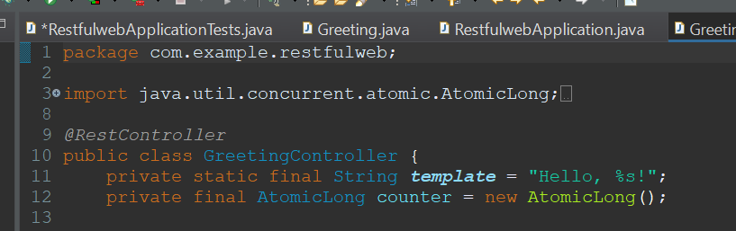

- These fields:
- private: These fields are private means its visible only in the class.
- Line 11 static: Static means it belongs to the GreetingController class, it does not belong to the object of the class.
- final: This means that it cannot be changed.
- Line 11 String: String is the data type.
- Line 11. The name of this variable is template. And the template is Hello %s!
so the %s! is going to be replaced with something, hence the name template.
- Line 12 AtomicLong: AtomicLong is going to be used as a counter. Its going to help us count from 1 to 2, 2 to 3, and so on.

- After the fields lets create the Controller method:
- So after the fields we are going to create a controller method.
- First write public Greeting greeting(String name){
}

Looks like this so far:
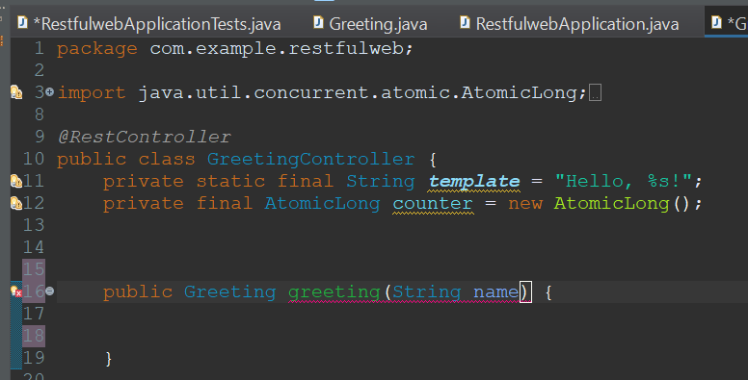

- So as of now this is a method that is a Greeting method and it returns a greeting object.
- Its public so its visible everywhere. Our Greeting object is from our Greeting record which itself takes a number and a String.

- So now in our Greeting method lets add a return statement and in this return statement we want to return a new greeting. So in the return type new Greeting and you need to match the constructor which passes two fields so in this return we need to pass two arguments to create the new greeting Object.
So far looks like this:
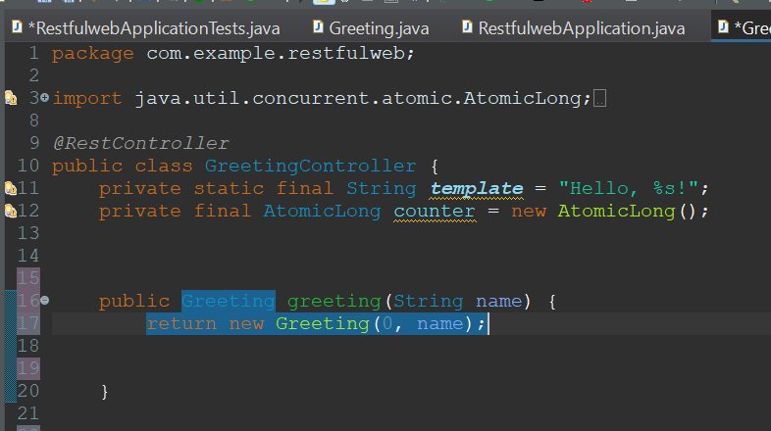
- As of now we just passed two arguments that will stop it from complaining but not exactly what we want to pass, so we will change it in a bit.
- Essentially this method named greeting takes an argument that is a name and returns a new greeting with a counter and a name.
- Quick note: From our previous practice when we return a method within a class except for MVC. Now when we use the @GetMapping it shows where we are returning the method to. We are not returning the method internally but returning it outside of our service to the front end since it’s a RESTful Web Service.

- So now above the method add @GetMapping annotation
- @GetMapping is an annotation for mapping Http get requests onto a specific handler method. So once we place this annotation above this method it will
be able to handle Http Get Requests.
- Now pass the endpoint so we will pass @GetMapping(“/greeting”) and once this method is hit with a request from this endpoint that is /greeting it will return a
new greeting to that endpoint.
Looks like this:
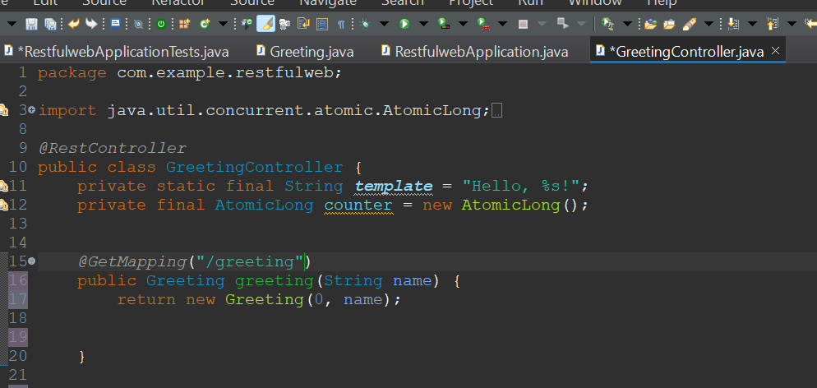

- Now in the method if we are returning a new greeting object isn’t that a Java Object?
- It is a Java Object
- But how are we returning a Java Object to our Front End:
- And how is this Java object going to be returned to our Body Response?
- Well this application uses Jackson JSON library to automatically marshal(transform) instances of type instance Greeting object into JSON. Jackson is included by the default web starter. This is when the Spring and Spring Boot come into play.
- So even though we are sending it back as a Java object. Its being transformed into a JSON object that be sent as a payload online.
- JSON is one of the payload types that can be sent. Payloads include these:
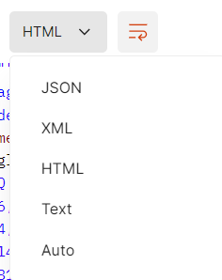

- And since our class has a @RestController it says that we should have a Response body.
- All of our methods with inside this @RestController annotated class should return a response to the caller/front end.

- Now in our method lets add @RequestParam and pass its values.
- And this will be tied to our String name
Looks like this: And make sure you import correctly.
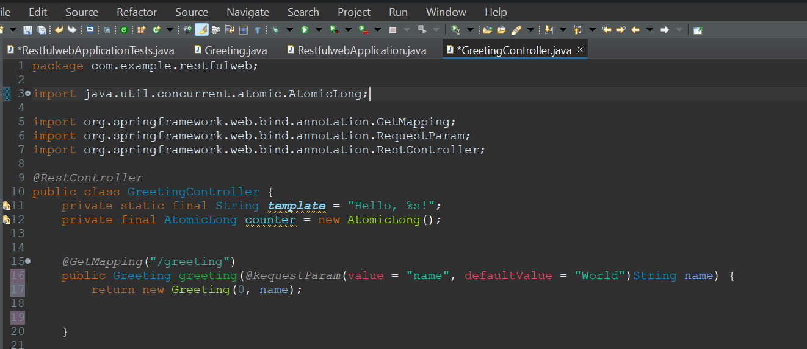

- @RequestParam: This annotation indicates that a method parameter(String name) should be bound to a web request parameter. So the String name is the backend and the other values in the @RequestParam are the frontend and they are binding together. String name is of type string.
- And now in our front end Params we pass some arguments.
- value = “name” is the first argument
- defaultValue = “world” is the second argument

- defaultValue: This is used to be a fallback when the request is not provided.

- Now lets use our fields in our method:
- In our return we are going to pass our counter object and we are going to use the incrementAndGet() method along with the counter object.
- incrementAndGet() this method atomically (one by one) will increment the current value, meaning 0 to 1, ,1 to 2, and so on.
- And the 2nd argument will be String(which is a static method of the String class) with the format method. And this format method is going to pass template, name.
- String.format() Inside it takes two arguments its going to take a format string which is our template and the 2nd argument is arguments referenced by the format specifiers in the format string. So we pass name which is going to take over %S! because Hello stays but after the comma is what name will replace which is %S! and the name itself is passed in from the front end.
- line 17 remember that the first name is the name you pass in the front end and the String name is the back end, share the same name because they are binded.
- Looks like this:
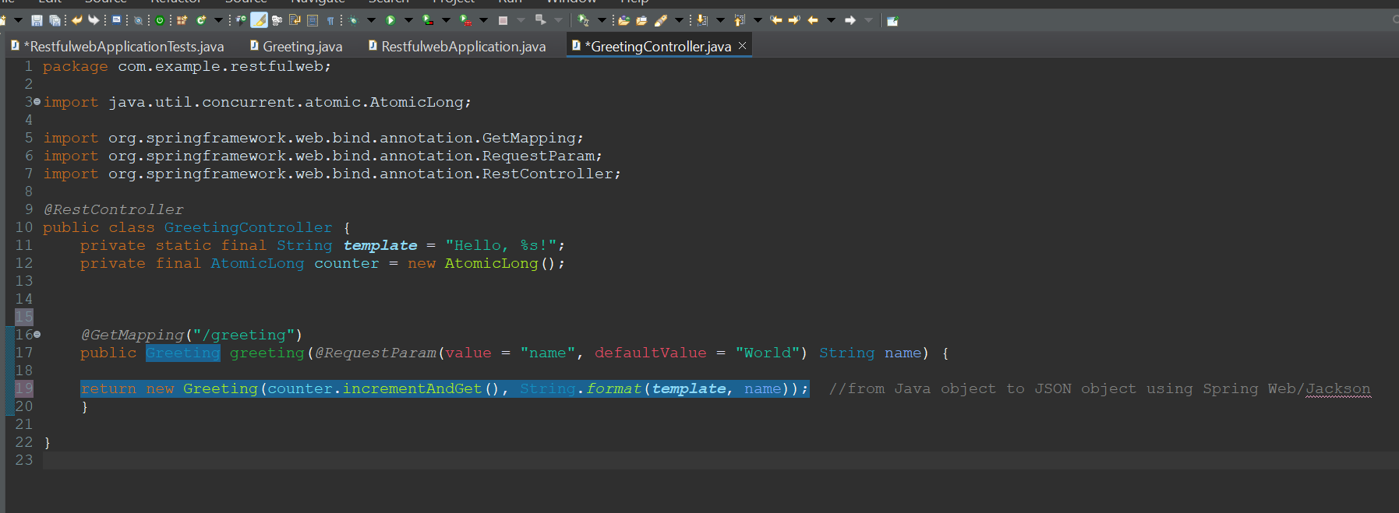

- So the name object that is in your backend parameter on line 17 is tied together with the name object on line 19.
- And with format we simply want to format the name object to fit the template which is hello %s! on line 11.
- Meaning that though query params if no name that is a String is passed, the default value will be World. So a given name like John will replace the %s! and it will be Hello John if no name is passed it will be Hello world.
- You can pass the name through the request body in Postman like this:
- Remember that you need to right click on project in the boot dashboard and restart for the application to run.
- Default port number is localhost:8080 our endpoint is /greeting and it will call our Greeting method.
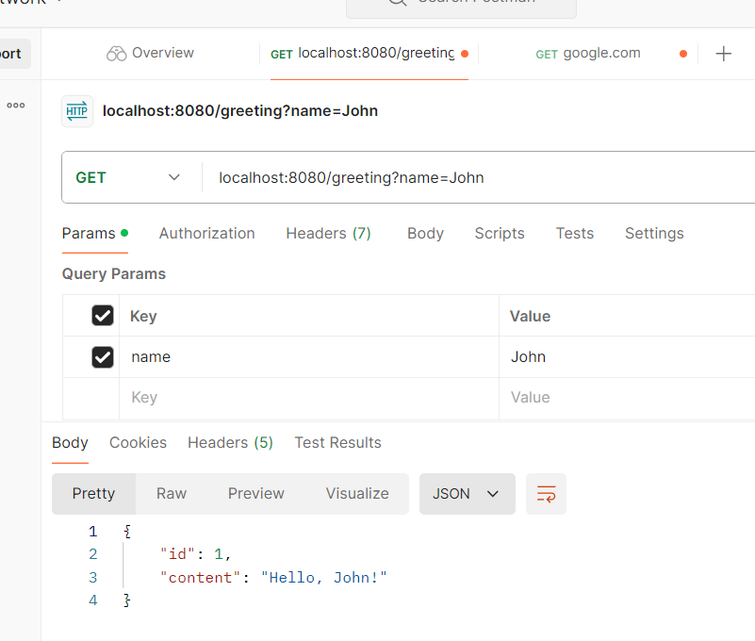
- So we are entering key value pairs. The key we use is the name and the value is what name we want to pass.
If no name is passed you will get the defaultValue:
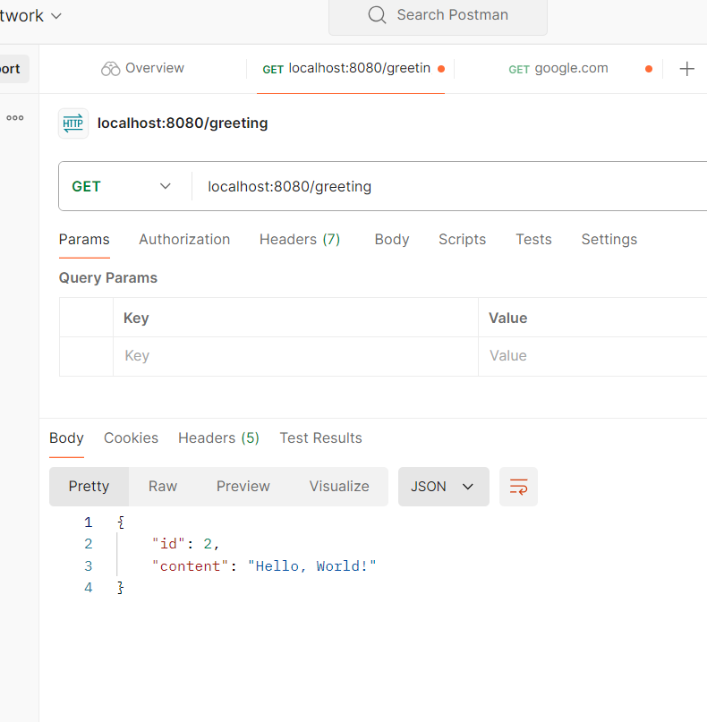

- Now in the first one you can either pass the key value pair in the body. Or pass the value through query params which means at the top in the URL. If you pass ?name=John it will still pass.

- You also notice id is 1 and id is 2 in the second. That’s because every time we enter on this endpoint regardless if we give a new value. We are firing the method so it is being executed and every time its called we have an automatic counter that increases 1 by 1. If you stopped the server and restarted it would start back from 1 again.

- Instead of PostMan run on Browser:
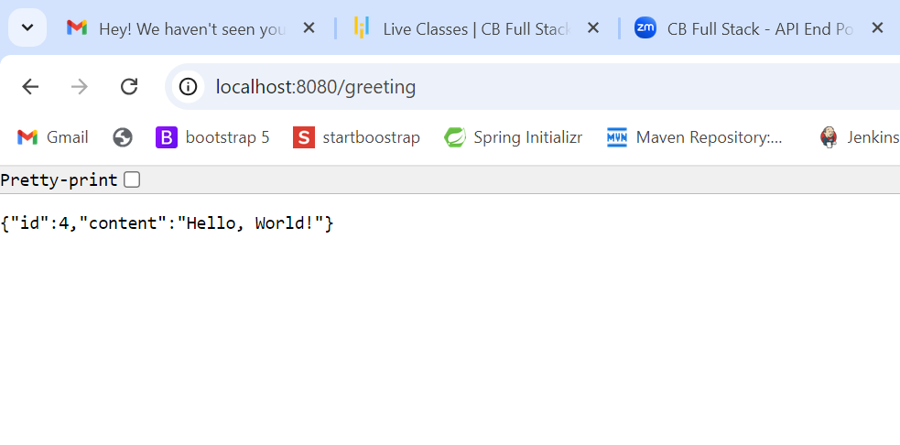
- With no value passed you get default that is World.
- Now pass query param meaning pass the value through the URL.
Like this:
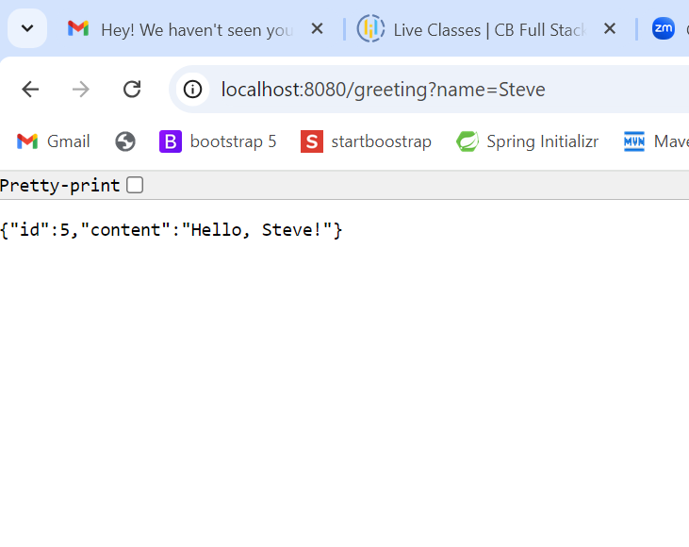

- And you can see that Steve is passed.
- We are going to explore the different ways of how we can pass information to our backend. We are going to get very knowledgeable with JSON, HTML, XML.

- Spring Starter:
- You can create the same project using Spring Starter Project:
- Click on file, new, spring starter project.
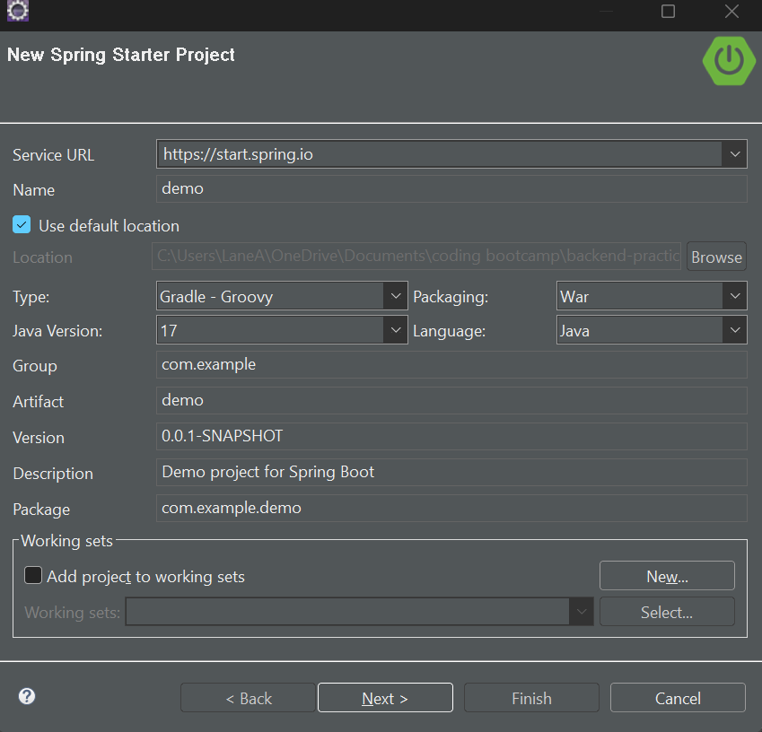

- This is the same as Spring Initializer.

- Create Another Class:
- In our Main package located in our Src/main/java lets right click on that package and create a new class called GoodbyeService.
- This class will be a service that allows us to say Goodbye just like the other one says Hello.
- Now in this class we are going to create a method called goodbye that returns a String so at the moment in the return you can pass a simple string.
Looks like this:
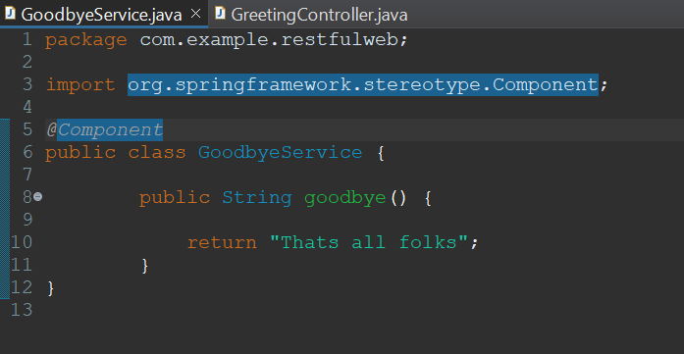

- And for this class lets make it an @Component
- And having this annotation makes it eligible as candidates for auto detection when using annotation based configuration and class scanning. And the class scanning is done with the @SpringBootApplication that is in our main class.

- So now instead of us creating an object again the class like
GoodBye goodbye = new GoodBye(); we have made it eligible. We have given Spring the authority to control it instead of having to create objects like that.

- Now go back to our GreetingController:
- And inside our Greeting method we are going to we have already returned our greeting but now we are going to add the goodbye.
- We are going to greet ourselves on the backend with goodbye and say hello on the
Front end.
- The first thing we need to do is bring in the GoodbyeService as a field.
- And if we want to make use of this we just need to @Autowired it.

Looks like this:
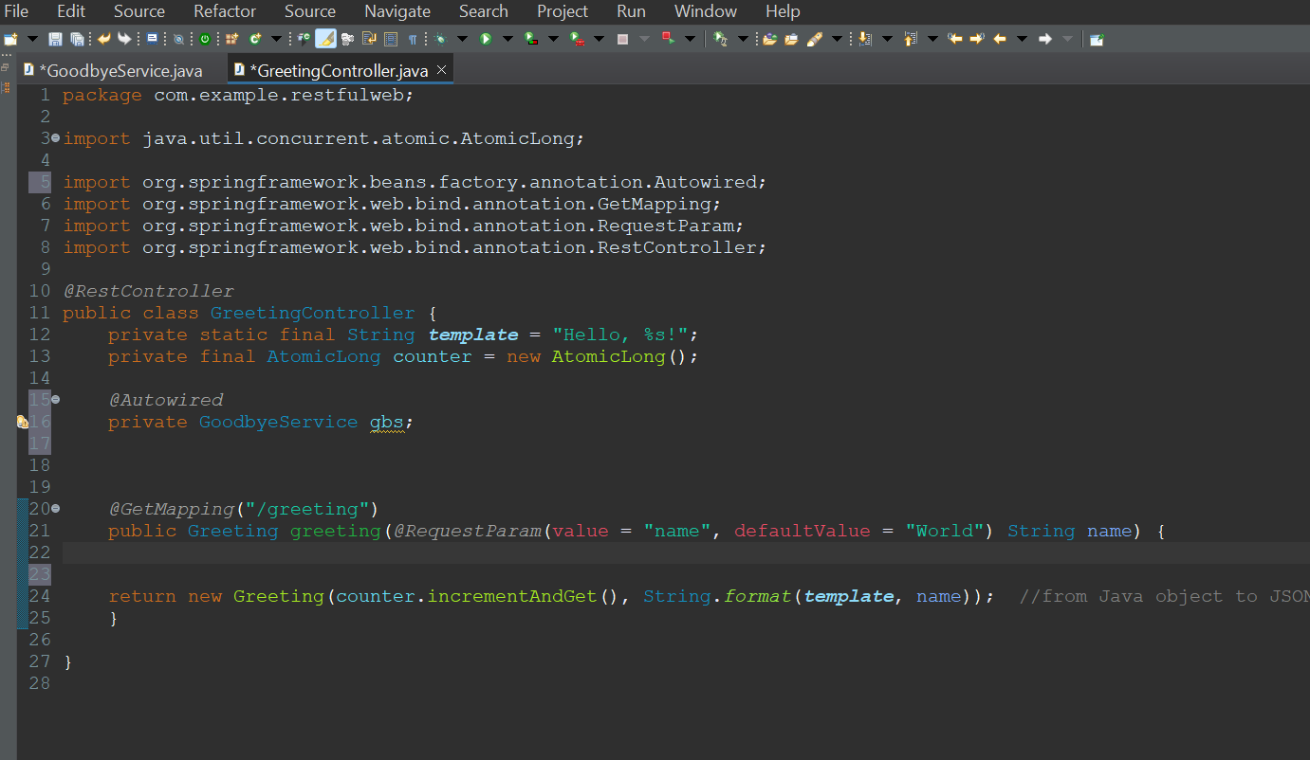

- Now that @Autowired that is a dependency injection.
- @Autowired: This annotation marks a constructor, field, or method to be autowired by Spring dependency injection facilities.
- So we basically said Spring Inject this dependency for us just in time for when we need it of the GoodbyeService
- So in the method we just pass gps. And the goodbye method which is the method we created in GoodbyeService and we will use it in a Print statement so only we see it on the backend.

Now looks like this:
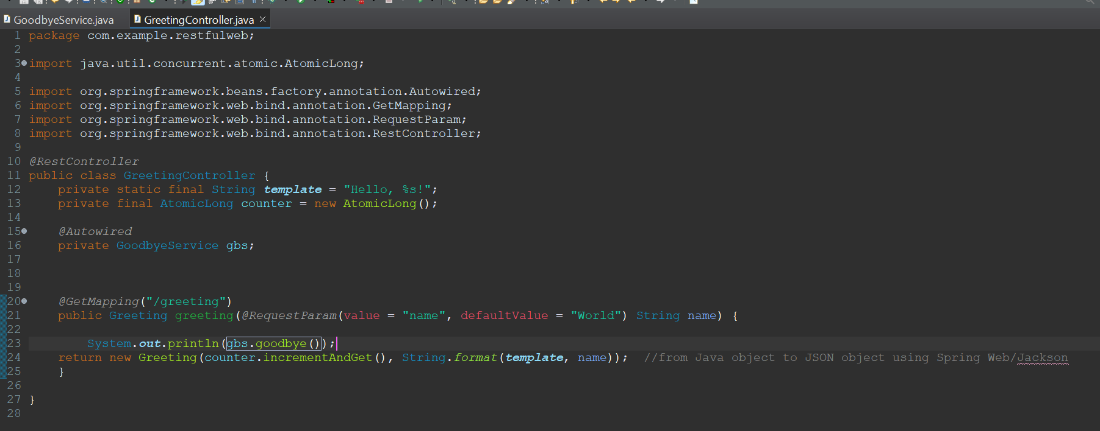
- Next time we will use a logger
- As of now what is happening?
- Its not about what the method does, its about the fact that by marking this class @Compoent that is the GoodbyeService class and then @Autowired that same class in our controller, we injected an object of GoodbyeService as gbs into our controller and now we can use it in our controller.
- And without using the new keyword we simply just access the method of that class we need. Like we did in line 23.

- Restart Application:
- Now lets run this to see the end changes. Restart application and run it again.
- And run a query in Postman
Looks like this:
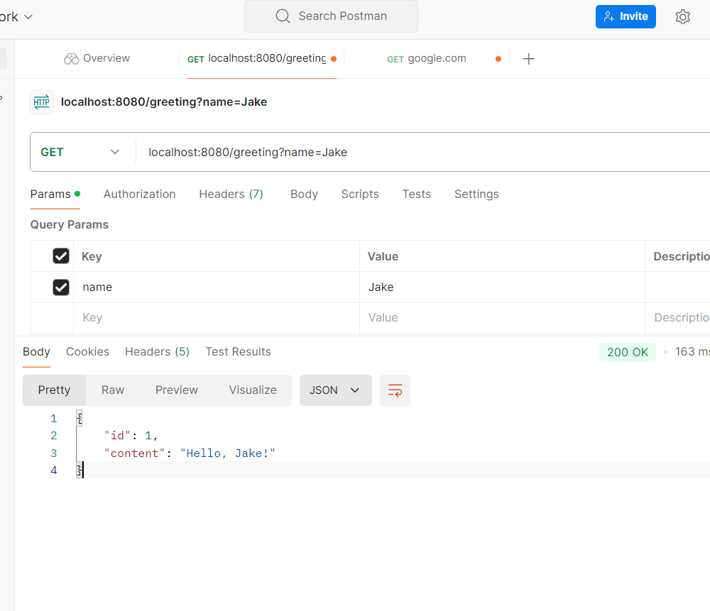

- Once you enter a query you can see that you get the goodbye message in your console after. Remember you do not get the goodbye just running the application. You have to trigger the endpoint first.

- Looks like this:
